For adding a new language:

1. In the case of adding a new country, first we have to duplicate an existing country folder and rename it according to the language code like : BE, FR. It will be easy for us if we duplicate FR or NL.
2. In the public directory there is an index.html and we have to add a new country in the option with a new country class like “option-flag-au”. Showing the flag will be added by the developer.

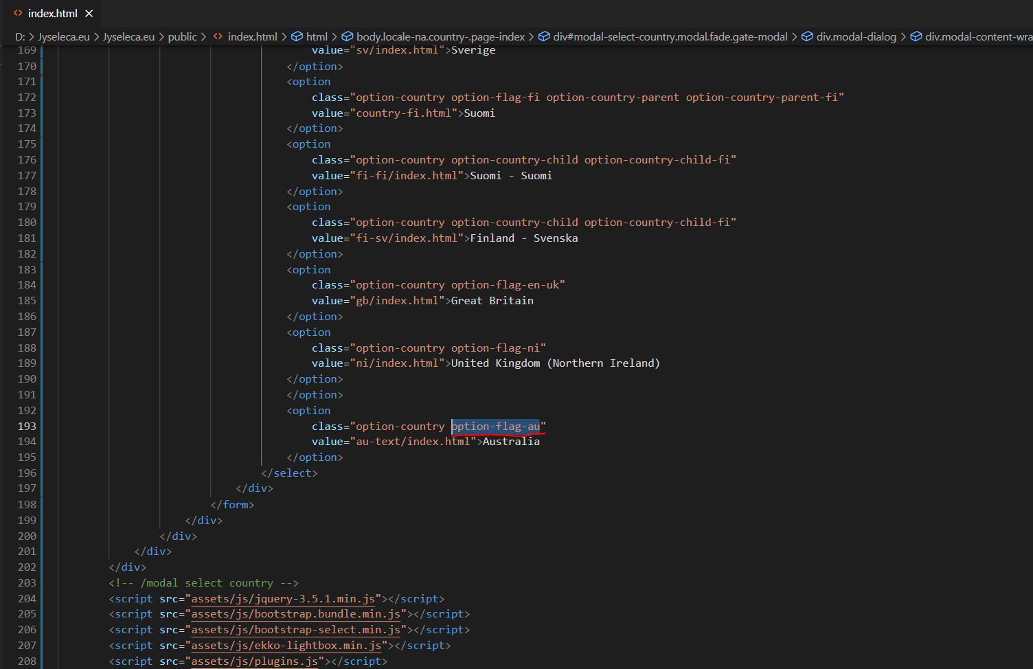

1. Then go to index.html and need to change all the text according to the new language
2. If we don't need the third button we have to remove it

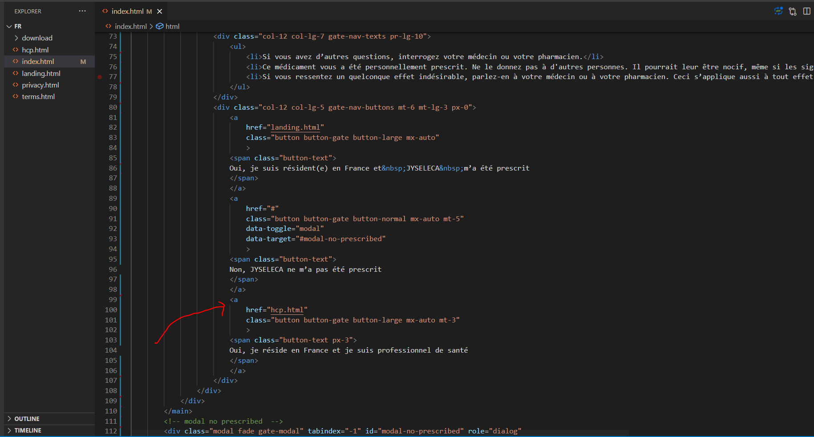

1. Change all footer text and it will be same for all the pages in a specific country

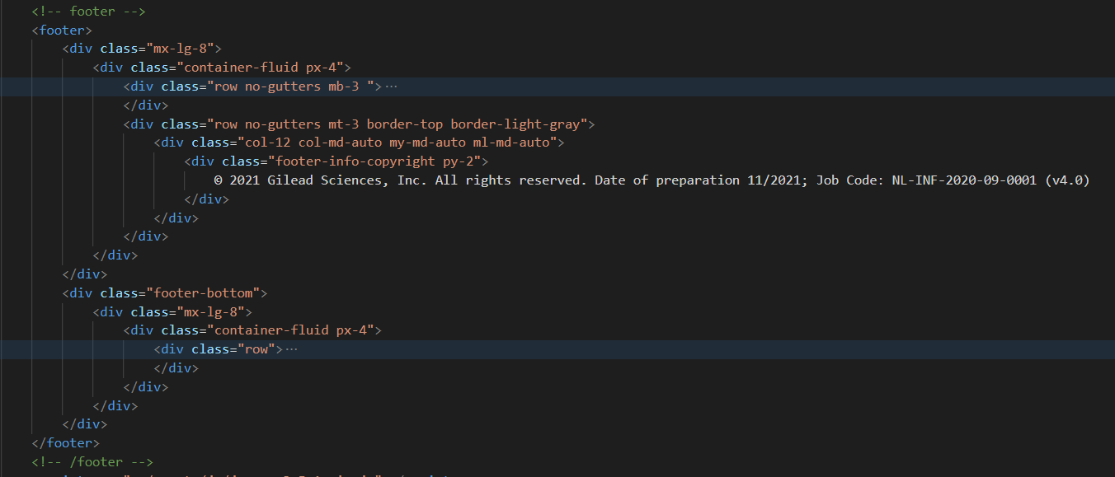

1. Then we can change text similarly for landing.html, hcp.html, privacy.html & terms.html pages.
2. For whitelist any domain just check the page bottom and add a URl 